Module 6
Hands on 1 - Spring Data JPA quick exqmple
OrmLearnApplication.java
package com.cognizant.ormlearn;

import java.util.List;
import javax.persistence.*;
import org.slf4j.Logger;
import org.slf4j.LoggerFactory;
import org.springframework.boot.*;
import org.springframework.boot.autoconfigure.SpringBootApplication;
import org.springframework.context.ApplicationContext;
import org.springframework.data.jpa.repository.JpaRepository;
import org.springframework.stereotype.Repository;
import org.springframework.stereotype.Service;
import org.springframework.beans.factory.annotation.Autowired;
import org.springframework.transaction.annotation.Transactional;

@SpringBootApplication
public class OrmLearnApplication {

private static final Logger LOGGER = LoggerFactory.getLogger(OrmLearnApplication.class);
private static CountryService countryService;

public static void main(String[] args) {
ApplicationContext context = SpringApplication.run(OrmLearnApplication.class, args);
LOGGER.info("Inside main");
countryService = context.getBean(CountryService.class);
testGetAllCountries();
}

private static void testGetAllCountries() {
LOGGER.info("Start");
List<Country> countries = countryService.getAllCountries();
LOGGER.debug("countries={}", countries);
LOGGER.info("End");
}
}

// Entity
@Entity
@Table(name = "country")
class Country {
@Id
@Column(name = "co_code")
private String code;

@Column(name = "co_name")
private String name;

public String getCode() { return code; }
public void setCode(String code) { this.code = code; }

public String getName() { return name; }
public void setName(String name) { this.name = name; }

@Override
public String toString() {
return "Country [code=" + code + ", name=" + name + "]";
}
}

// Repository
@Repository
interface CountryRepository extends JpaRepository<Country, String> {
}

// Service
@Service
class CountryService {

@Autowired
private CountryRepository countryRepository;

@Transactional
public List<Country> getAllCountries() {
return countryRepository.findAll();
}
}
OUTPUT
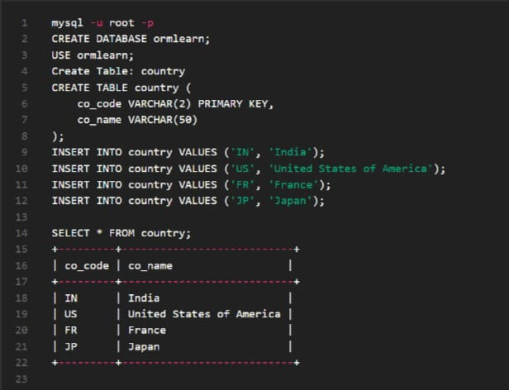

HANDS ON 5 - Implement services for managing Country
CountryApp.java
package com.example.country;

import org.springframework.beans.factory.annotation.Autowired;
import org.springframework.boot.CommandLineRunner;
import org.springframework.boot.SpringApplication;
import org.springframework.boot.autoconfigure.SpringBootApplication;
import org.springframework.data.jpa.repository.*;
import org.springframework.data.repository.query.Param;

import javax.persistence.*;
import java.util.List;
import java.util.Optional;

// Main Application
@SpringBootApplication
public class CountryApplication implements CommandLineRunner {

@Autowired
private CountryRepository countryRepository;

public static void main(String[] args) {
SpringApplication.run(CountryApplication.class, args);
}

@Override
public void run(String... args) throws Exception {
// 1. Find country by code
System.out.println("Country with code 'IN': " + countryRepository.findById("IN").orElse(null));

// 2. Add new country
Country newCountry = new Country("XX", "Testland");
countryRepository.save(newCountry);
System.out.println("Added country: " + newCountry);

// 3. Update country
Optional<Country> countryToUpdate = countryRepository.findById("XX");
if (countryToUpdate.isPresent()) {
countryToUpdate.get().setName("Updated Testland");
countryRepository.save(countryToUpdate.get());
System.out.println("Updated country: " + countryToUpdate.get());
}

// 4. Delete country
countryRepository.deleteById("XX");
System.out.println("Deleted country with code 'XX'");

// 5. Search countries by partial name
List<Country> matches = countryRepository.findByNameContainingIgnoreCase("land");
System.out.println("Countries containing 'land':");
matches.forEach(System.out::println);
}
}

// Entity
@Entity
@Table(name = "country")
class Country {
@Id
@Column(name = "co_code")
private String code;

@Column(name = "co_name")
private String name;

public Country() {}

public Country(String code, String name) {
this.code = code;
this.name = name;
}

public String getCode() { return code; }
public void setCode(String code) { this.code = code; }

public String getName() { return name; }
public void setName(String name) { this.name = name; }

@Override
public String toString() {
return code + " - " + name;
}
}

// Repository
interface CountryRepository extends JpaRepository<Country, String> {
List<Country> findByNameContainingIgnoreCase(@Param("name") String name);
}
OUTPUT
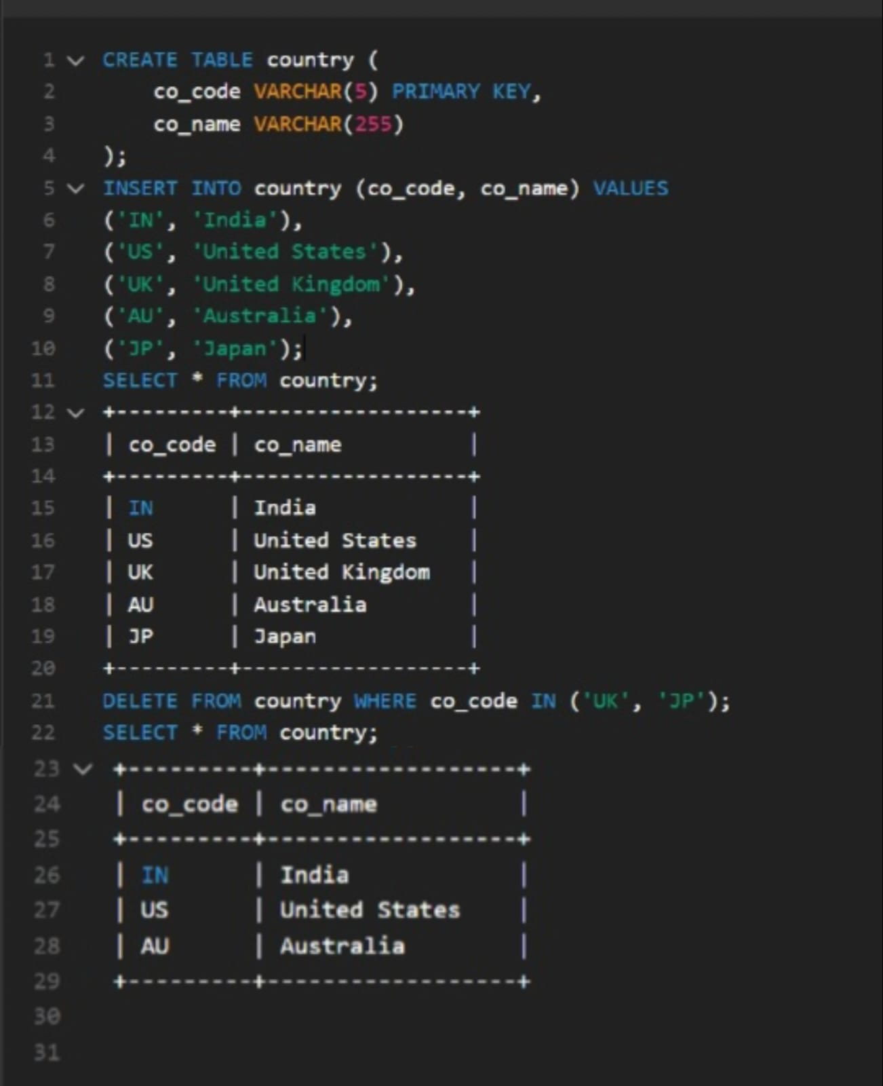
Hands on 6 – Find a country based on country code
package com.cognizant.spring_learn;

import jakarta.persistence.Entity;
import jakarta.persistence.Id;
import org.slf4j.Logger;
import org.slf4j.LoggerFactory;
import org.springframework.boot.SpringApplication;
import org.springframework.boot.autoconfigure.SpringBootApplication;
import org.springframework.context.annotation.Bean;
import org.springframework.boot.CommandLineRunner;
import org.springframework.data.jpa.repository.JpaRepository;
import org.springframework.stereotype.Service;
import org.springframework.transaction.annotation.Transactional;

import java.util.Optional;

import org.springframework.beans.factory.annotation.Autowired;

@SpringBootApplication
public class OrmLearnApplication {

private static final Logger LOGGER = LoggerFactory.getLogger(OrmLearnApplication.class);

public static void main(String[] args) {
SpringApplication.run(OrmLearnApplication.class, args);
}

@Bean
CommandLineRunner run(CountryService countryService) {
return args -> {
LOGGER.info("Start");

try {
Country country = countryService.findCountryByCode("IN");
LOGGER.debug("Country: {}", country);
} catch (CountryNotFoundException e) {
LOGGER.error("Exception: {}", e.getMessage());
}

LOGGER.info("End");
};
}

// Model
@Entity
public static class Country {
@Id
private String code;
private String name;

public Country() {}

public Country(String code, String name) {
this.code = code;
this.name = name;
}

public String getCode() { return code; }
public void setCode(String code) { this.code = code; }

public String getName() { return name; }
public void setName(String name) { this.name = name; }

@Override
public String toString() {
return "Country [code=" + code + ", name=" + name + "]";
}
}

// Repository
public interface CountryRepository extends JpaRepository<Country, String> {}

// Exception
public static class CountryNotFoundException extends Exception {
public CountryNotFoundException(String message) {
super(message);
}
}

// Service
@Service
public static class CountryService {

@Autowired
private CountryRepository countryRepository;

@Transactional
public Country findCountryByCode(String countryCode) throws CountryNotFoundException {
Optional<Country> result = countryRepository.findById(countryCode);
if (!result.isPresent()) {
throw new CountryNotFoundException("Country with code " + countryCode + " not found.");
}
return result.get();
}
}
}
OUTPUT
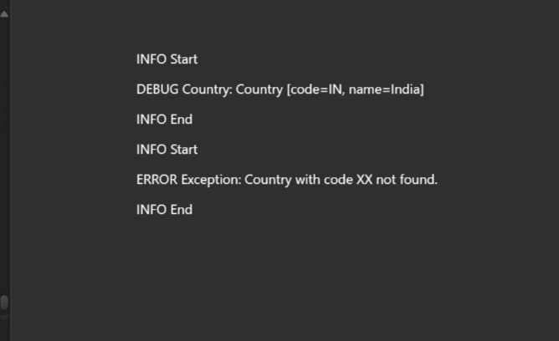

File 2
Difference between JPA, Hibernate and Spring Data JPA
Point | JPA | Hibernate | Spring Data JPA
1. Type | Specification (API) | Framework (Implementation of JPA) | Spring-based abstraction over JPA
2. Creator | Java EE / Jakarta EE | Red Hat | Spring Team (Pivotal)
3. Purpose | Defines ORM rules and APIs | Implements JPA and adds extra features | Simplifies JPA usage in Spring
4. Implementation Required | Yes (e.g., Hibernate) | No, it is an implementation | Yes, requires JPA implementation like Hibernate
5. Level of Abstraction | Low-level | Mid-level | High-level
6. Boilerplate Code | High (manual EntityManager, DAO) | Moderate | Very low (auto repository generation)
7. Repository Support | Not provided | Requires custom DAOs | Provides CrudRepository, JpaRepository
8. Query Language | JPQL, Criteria API | JPQL, HQL, Native SQL | JPQL, Native SQL, and method name-based queries
9. Caching Support | Basic (annotations) | Strong (1st & 2nd level cache) | Depends on underlying JPA provider (e.g., Hibernate)
10. Ease of Use | Complex | Easier than JPA | Easiest, Spring-friendly
11. Configuration | Manual (XML or Java-based) | XML or annotation-based | Auto-configured with Spring Boot
12. Transactions | Manually handled using EntityManager | Built-in support | Uses @Transactional easily with Spring
13. Learning Curve | Steep | Moderate | Beginner-friendly if familiar with Spring
14. Integration | Requires more setup | Integrates with frameworks manually | Seamlessly integrates with Spring ecosystem
15. Testing Support | Manual setup for testing | Slightly easier | Excellent support with Spring Boot (@DataJpaTest)

